Table of Contents

Page No.

1. Downloading code from github 2
2. Installing Android Studio 3
3. Installing Arduino IDE 4
4. Installing Jupyter Notebook 5
5. Run prediction model codes on jupyter notebook 6
6. Upload code to ESP from Arduino IDE 7

Downloading code from github

1. Go to the link ‘<https://github.com/shivamgohri/intelliJ>’.
2. Download the zipped file.
3. Extract the files and execute them.

Installing Android Studio

1. Go to <https://developer.android.com/studio> .
2. Click ‘Download Android Studio’ button.

[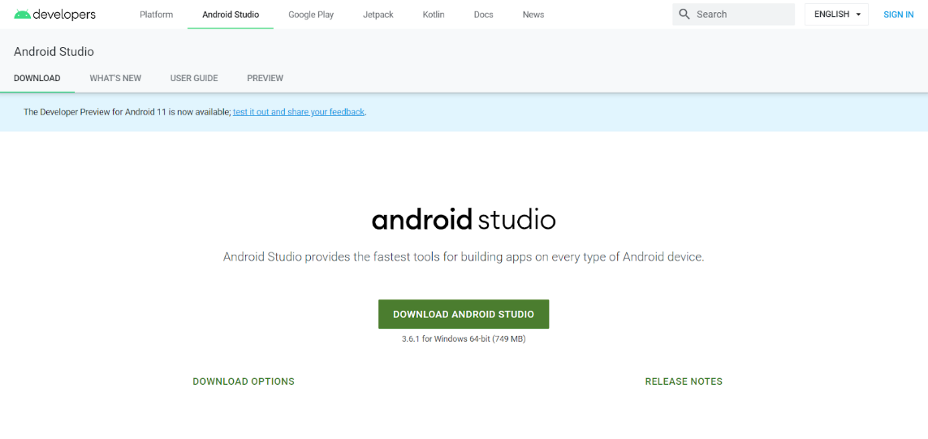](https://developer.android.com/studio)

1. Set up the Android Studio.

Installing Arduino IDE

1. Go to <https://www.arduino.cc/en/Main/Software> .
2. Download software according to your platform.

[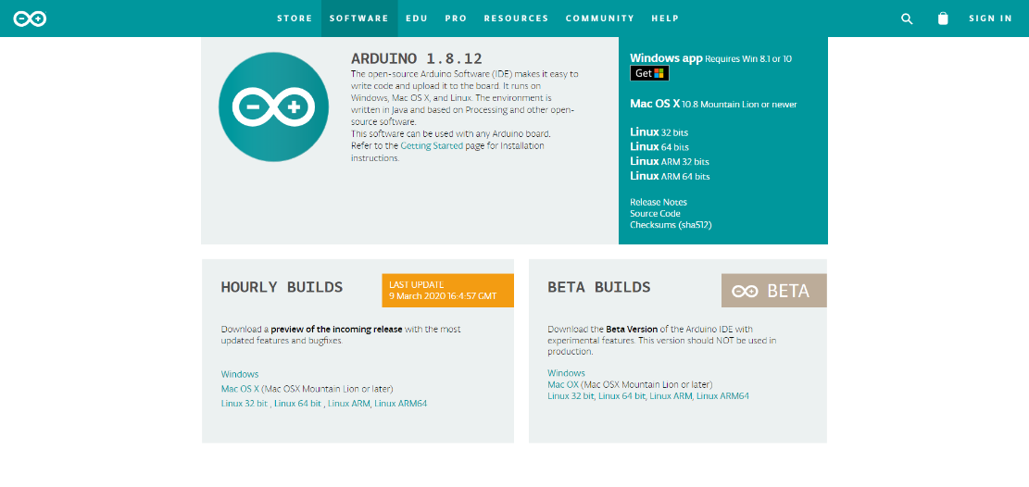](https://www.arduino.cc/en/Main/Software)

1. Set up the Arduino IDE.

Installing Jupyter Notebook

1. Installing Jupyter Notebook:

* 1. Using conda : If you use conda then run the following command in anaconda command prompt.

*conda install –c conda-forge notebook*

* 1. Using pip :
     1. Run the following command in command prompt.

*Pip install notebook*

* + 1. Run the following command in command prompt(Windows)

*Jupyter notebook*

1. Installing Python Libraries:

Install python libraries such as pandas, Numpy, Scipy, matplotlib, sklearn, keras, cv2 etc.

(To install numpy run the following command in command prompt

*pip install numpy*)

Run Prediction Model Codes in Jupyter Notebook

1. To run code for plant disease detection run the following command in terminal:

*./disease_detection_code.ipynb*

1. To run code for pest detection run the following command in terminal:

*./pest_detection_code.ipynb*

1. To run the code for weed detection run the following command in terminal:

*./weed_detection_code.ipynb*

Uploading code to ESP from Arduino IDE

1. Connect ESP board to the computer using a serial-USB converter.
2. In the Tools->Boards tab choose “Generic ESP8266 module”.

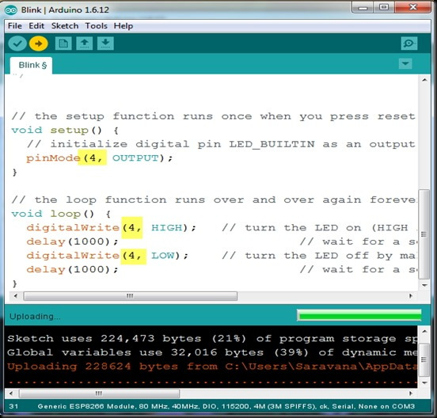

1. Click upload to upload the code to ESP board.
2. For connections refer to ‘hardware_code.ino’.